[**https://www.youtube.com/watch?v=TiSGujM22OI&list=PLC3y8-rFHvwgg3vaYJgHGnModB54rxOk3&index=93**](https://www.youtube.com/watch?v=TiSGujM22OI&list=PLC3y8-rFHvwgg3vaYJgHGnModB54rxOk3&index=93)

**React +Typescript**

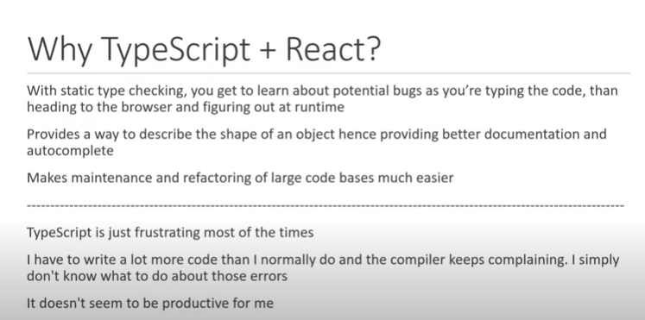

**But your release typescript is does not complex.**

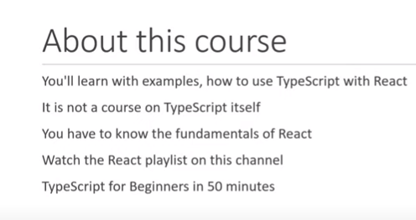

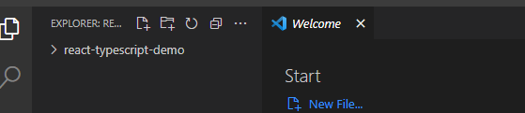

**Cmd – npx create-react-app react-typescript-demo –template typescript**

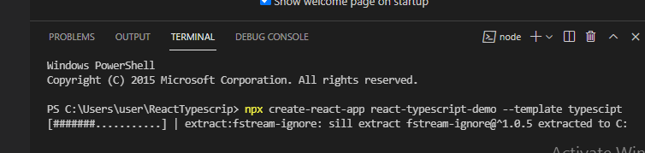

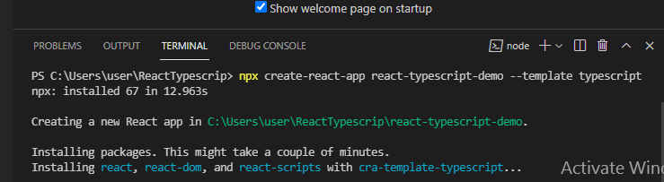

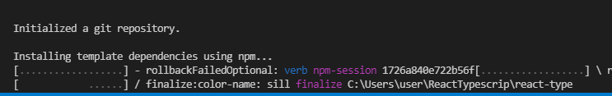

**Navigate to project and give command npm start or** yarn start

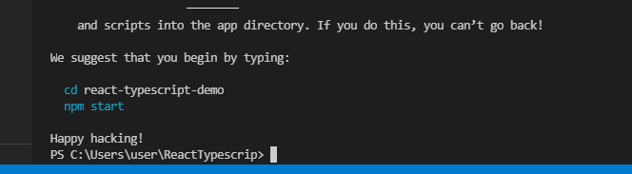

Navigate to application name i.e react-typescript-demo and give cmd-npm start

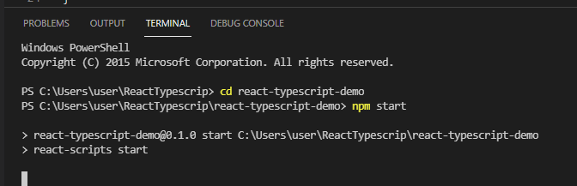

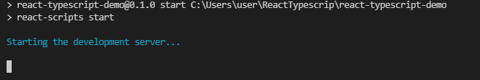

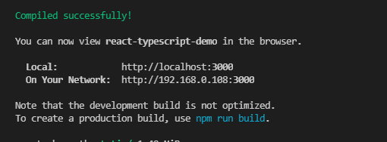

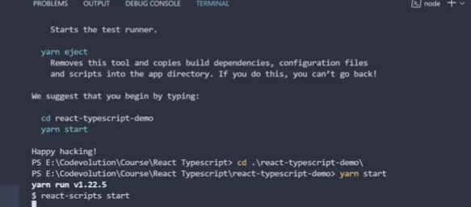

**Application on browser**

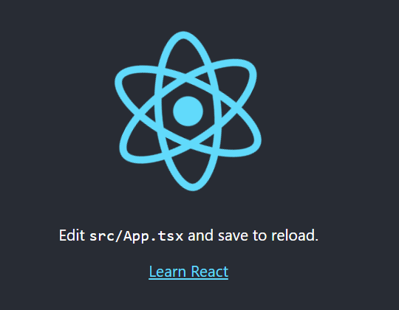

**Index.tsx file is the entry point**

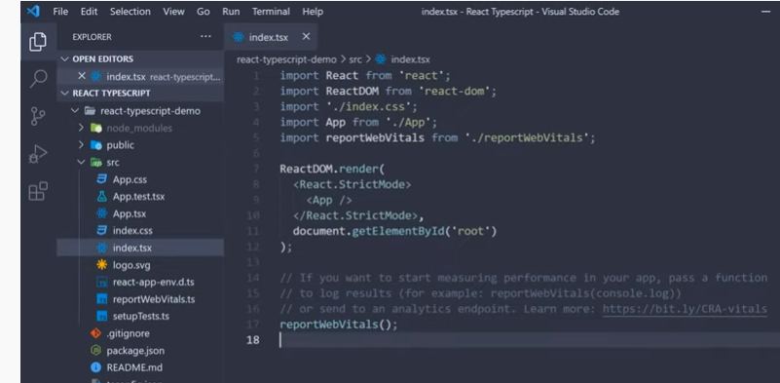

**App.tsx –root component**

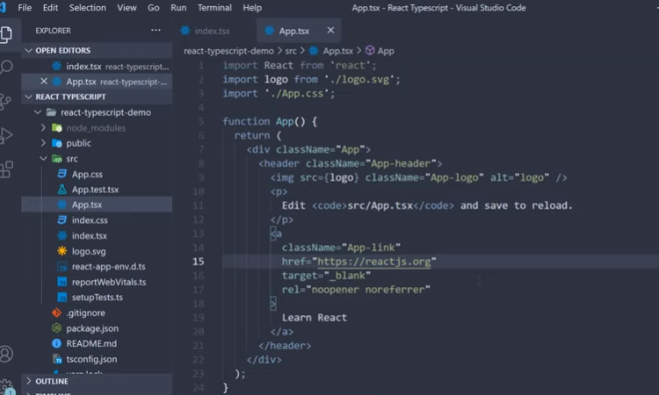

**Unlike regular its just extension difference like – tsx**

**Both index.tsx and app.tsx is similar react index.js and app.js**

**But when hover you can view –function App(); JSX. Element –typeinference**

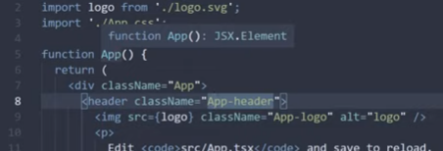

**Remove unnessary code for our coding - header content**

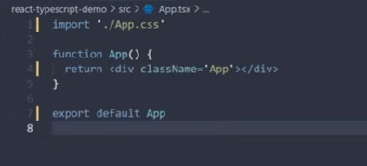

**In source folder create component folder**

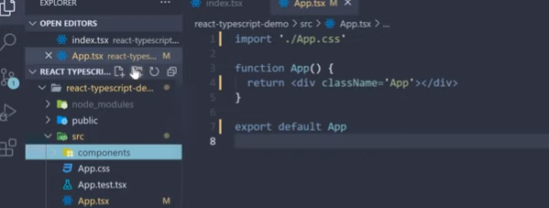

[**https://www.youtube.com/watch?v=KpA6oEaCHtk&list=PLC3y8-rFHvwgg3vaYJgHGnModB54rxOk3&index=95**](https://www.youtube.com/watch?v=KpA6oEaCHtk&list=PLC3y8-rFHvwgg3vaYJgHGnModB54rxOk3&index=95)

React TypeScript Tutorial - 3 - Typing Props

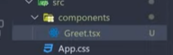

**Props are essential to build any react practical applications**

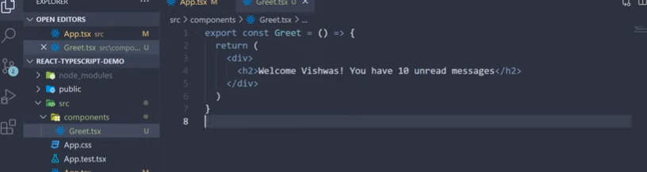

**In app.tsx**

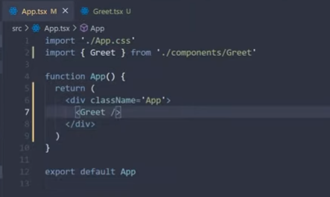

**Output on browser**

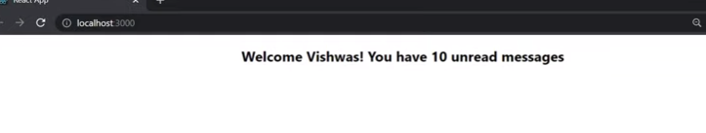

**Lets make few changes in the code**

**App.tsx**

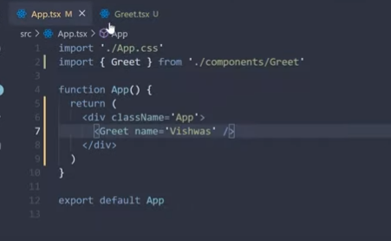

**Define the Greet name = “Vishwas’ –it should string**

**In Greet.tsx**

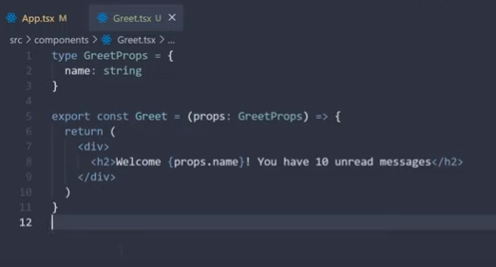

**How to define the type of props ? string/integer ..**

**Type GreetProps = {**

**Name : String**

**}**

**Export const Greet = (props : GreetProps) => {}**

**If you define other type. It will error**

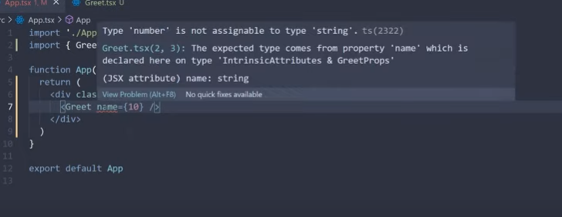

**Flow**

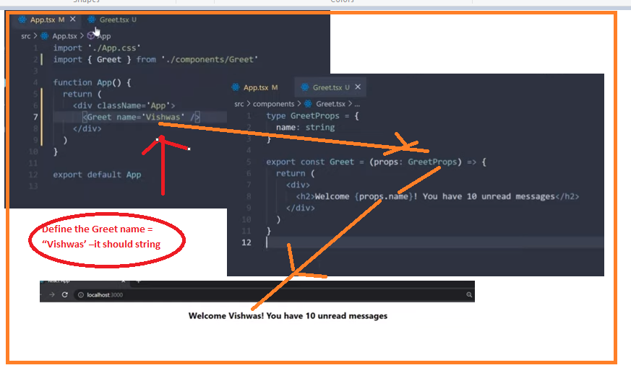

**\*\*\*Use type when using the applications and use interface when building the libaraires.**

[**https://www.youtube.com/watch?v=mDu54a5U3OU&list=PLC3y8-rFHvwgg3vaYJgHGnModB54rxOk3&index=96**](https://www.youtube.com/watch?v=mDu54a5U3OU&list=PLC3y8-rFHvwgg3vaYJgHGnModB54rxOk3&index=96)

# React TypeScript Tutorial - 4 - Basic Props

**few more changes in the application**

**define string, number and Boolean ( Define ternary operation)**

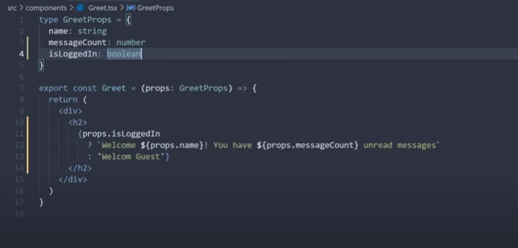

**Need to declare the values too. – passing the values from Class declaration.**

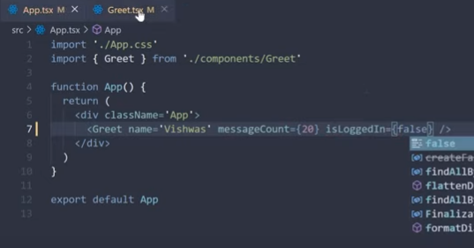

**Lets create the type GreetProps =**

**{**

**name:String**

**messageCount:**

**number isLoggedIn: boolean**

**}**

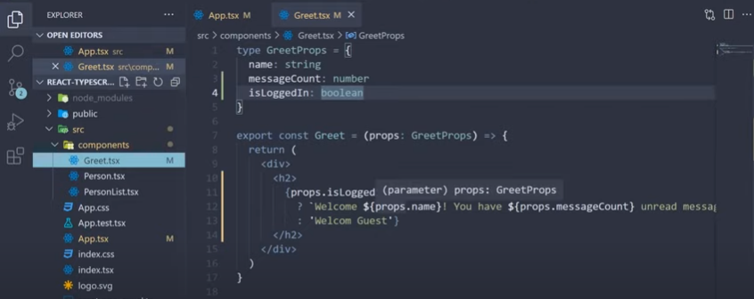

**Output :-**

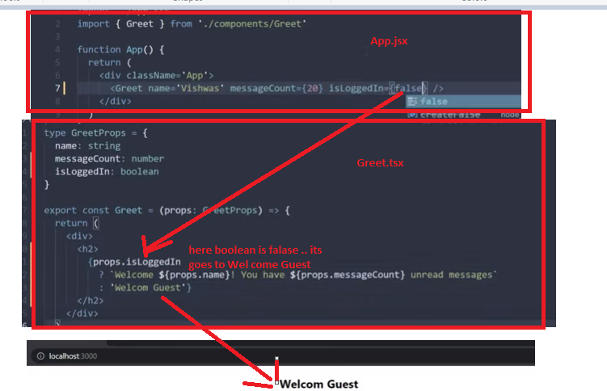

**Lets create the person.tsx component (its object)**

* **When we declare the export conts – its seems to component**

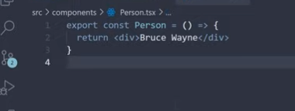

**As we have hard coded first and last name in the Person component**

**Lets pass in the props : -**

**(How to create the properties)**

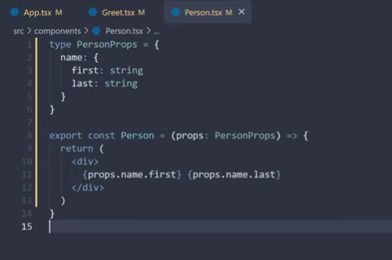

**In App.tsx – import person and <Person name = {personName}>**

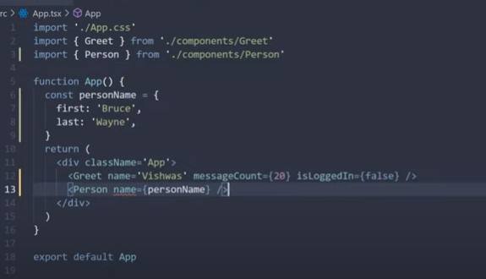

**Flow :-**

**How to define the properties in the react and how to call those properties in the return**

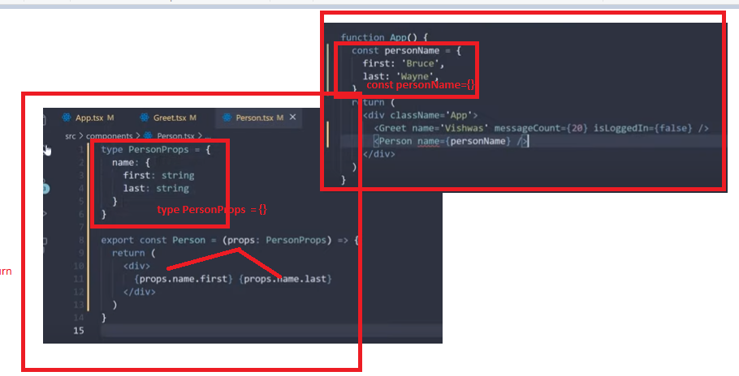

**Array : - list of three names**

**Lets typing an array : - PersonList.tsx**

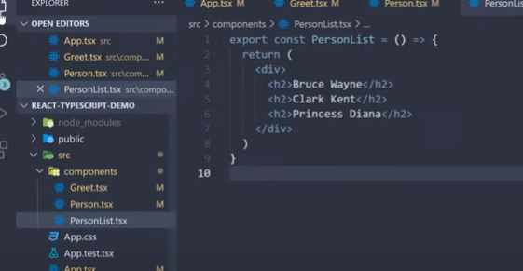

**In App.tsx**

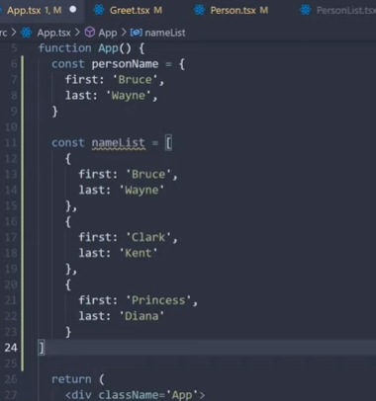

**As you can see its compilation error fix this..**

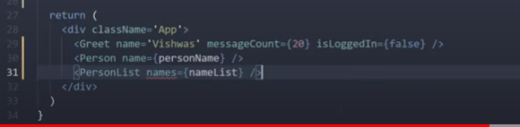

**In personlist.tsx**

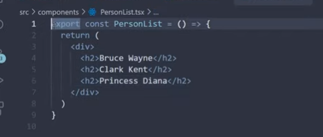

**Make changes in the above code**

**Define type of fileds pass i.e string and array[] at end**

**-out is list so use map()**

**How to declare the list of array properties in the react**

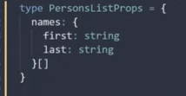

**How to call those list of properties in the react return..**

**Using the map and key props.**

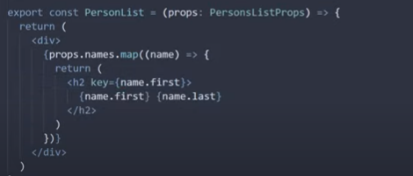

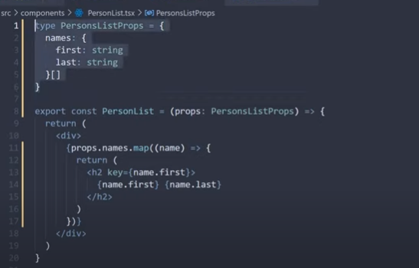

**As we have worked fileds-**

**String, number and boolean**

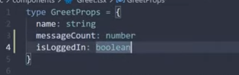

**Object**

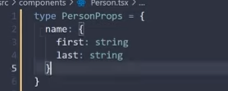

**Arrays**

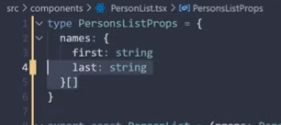

**Flow**

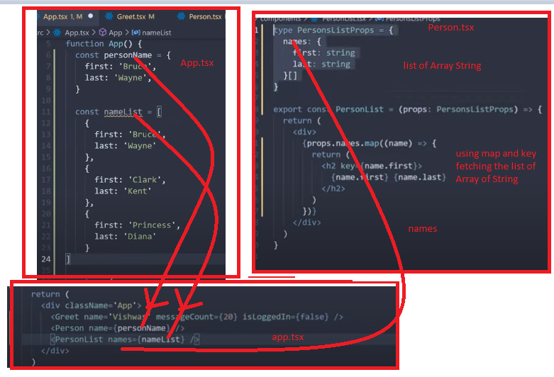

[**https://www.youtube.com/watch?v=zLyeWSfTMa8&list=PLC3y8-rFHvwgg3vaYJgHGnModB54rxOk3&index=97**](https://www.youtube.com/watch?v=zLyeWSfTMa8&list=PLC3y8-rFHvwgg3vaYJgHGnModB54rxOk3&index=97)

# React TypeScript Tutorial - 5 - Advanced Props

**Passing the properties in if else condition**

**S1- create the App.tsx**

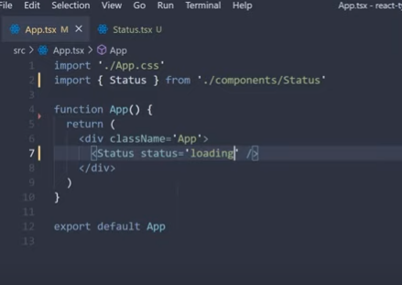

**S2- Status.tsx**

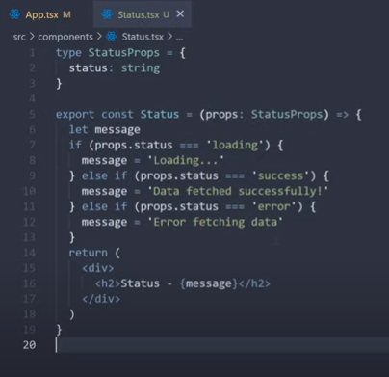

**Status.tsx & App.tsx**

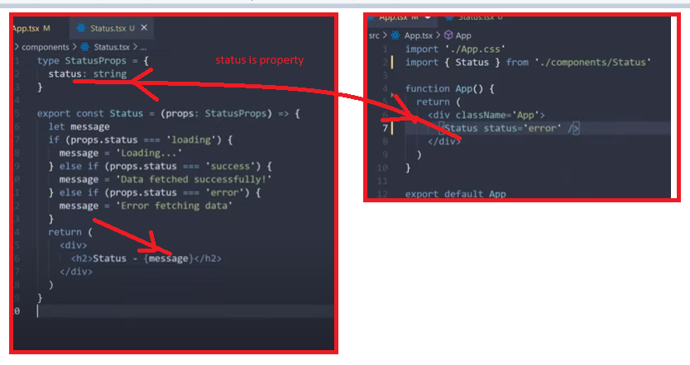

Changes in the above code in App.tsx :-

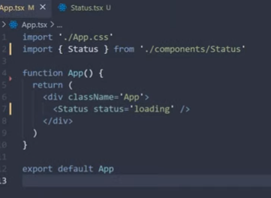

Status.tsx : -

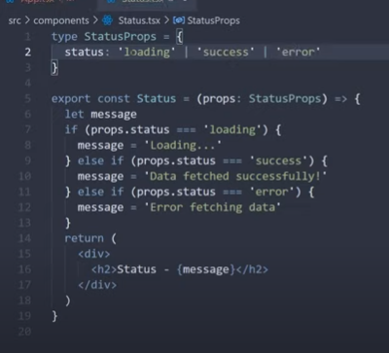

Flow:- union defined like loading | success | error

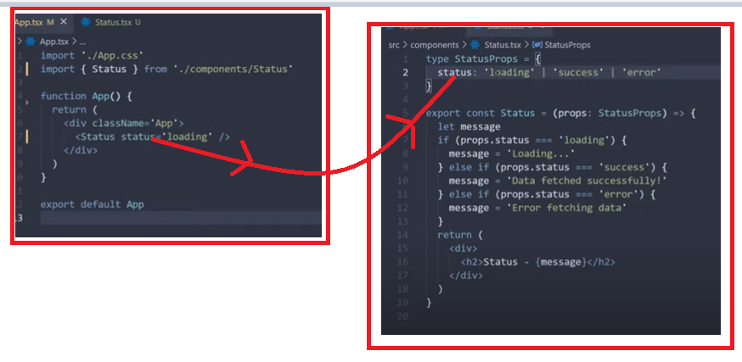

Lets define the Heading.tsx

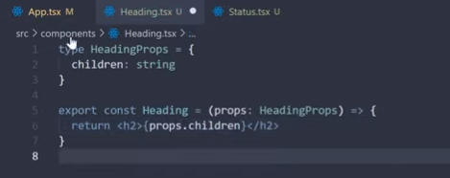

App.tsx

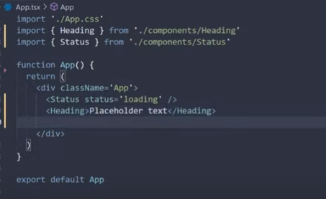

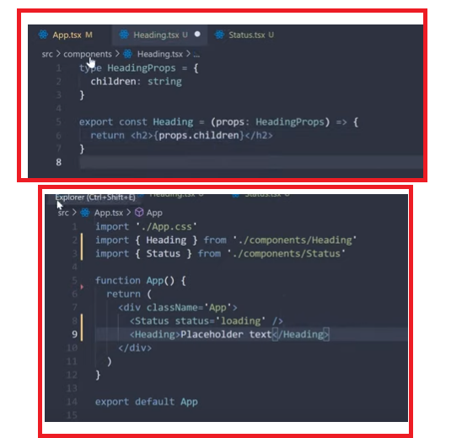

Lets define Oscar.tsx

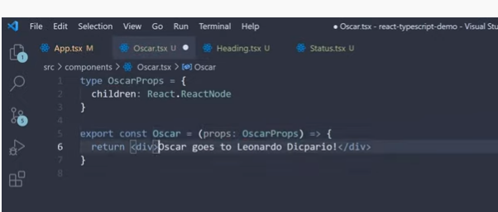

If you are using react 16 – import react .. or if you are using react 17 then dependencies we have this – @types/react

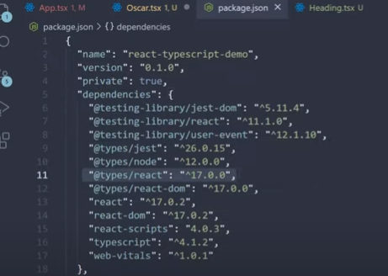

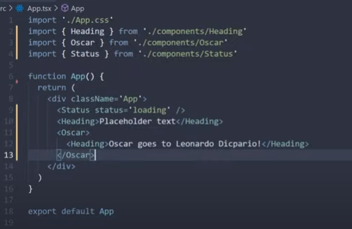

Now calling the all components –Greet, Heading, Oscar and Status

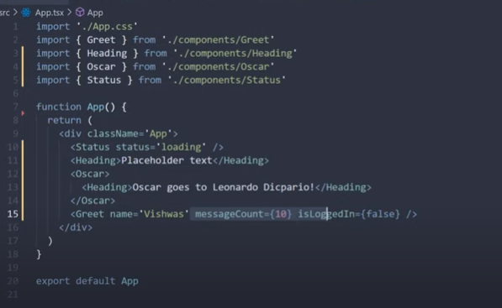

In the above code under Greet ,Name, messageCount and IsLoggedIn are mandatory

And if want to make messageCount ={} – is Optional –then we can define with the ?

In the Greet.tsx

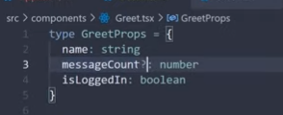

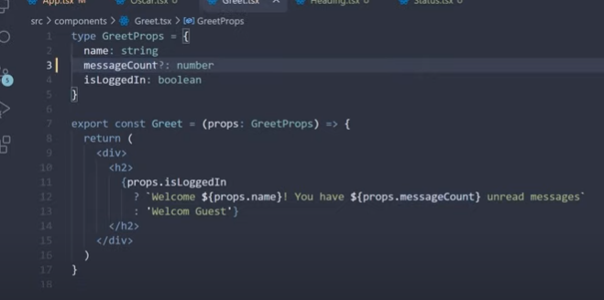

In App.tsx- no error at Greet.

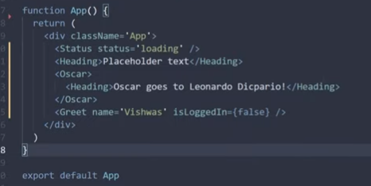

Lets define the value from our end or default value for the message.

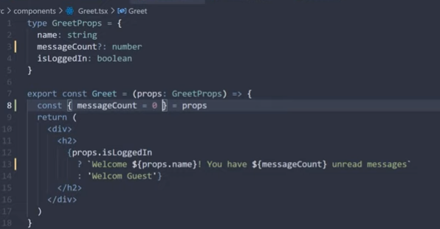

type GreetProps = {

messageCount? = number

}

Cont {messageCount = 0} = props

How to define the default property in react.

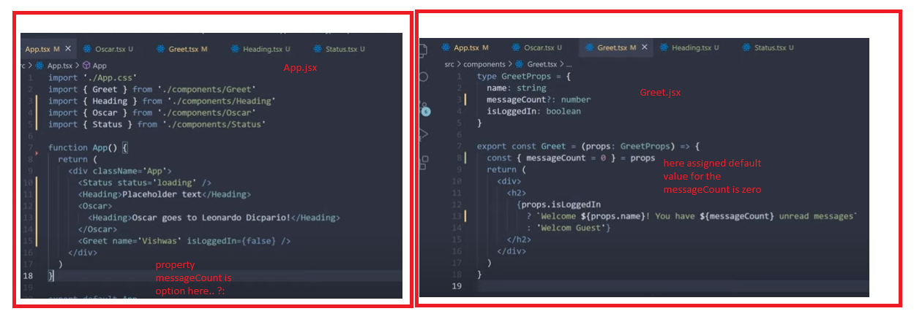

# React TypeScript Tutorial - 6 - Event Props

<https://www.youtube.com/watch?v=xNSIHFi8o2M&list=PLC3y8-rFHvwgg3vaYJgHGnModB54rxOk3&index=98>

Event- click event on button and change event on input element.

Button related : -

Function with return void

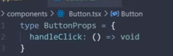

Step 1- Click Handler

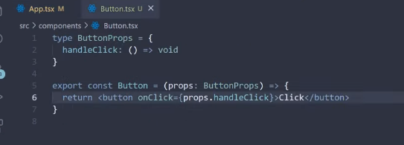

Step2

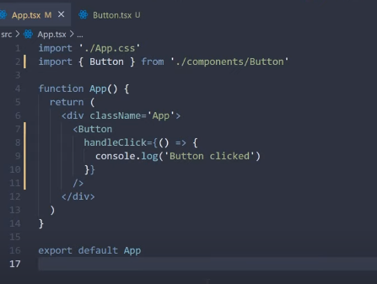

Flow of Button Event

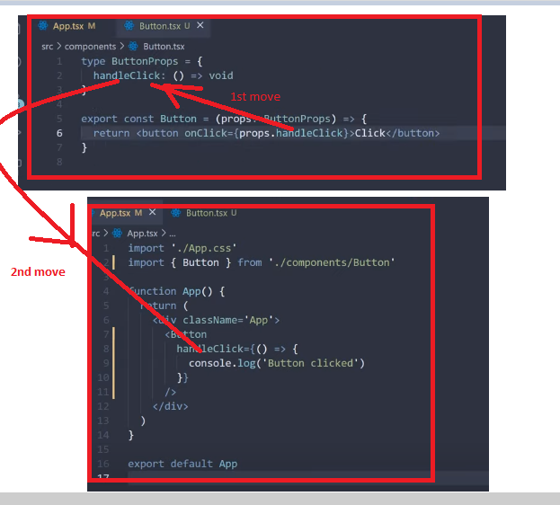

Another method for button event – we have button element in the typescript environment

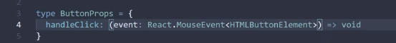

S1- event: React.MouseEvent<HTMLButtonElement

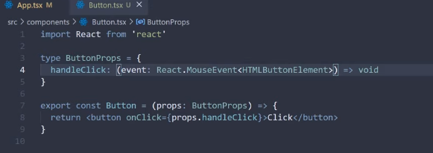

S2-

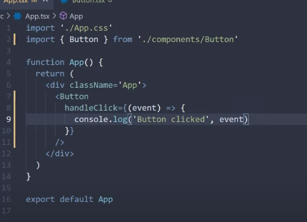

Flow : Event .. Click



We can pass the id in the event.

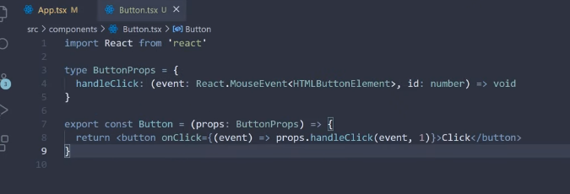

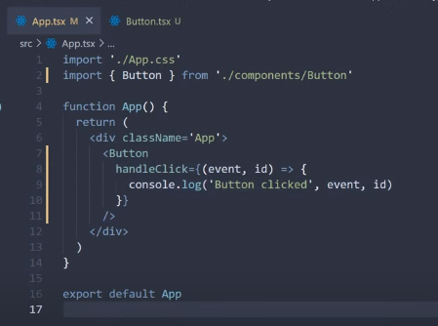

2nd Eg: On Change Event :-

handleChange is function return type is void

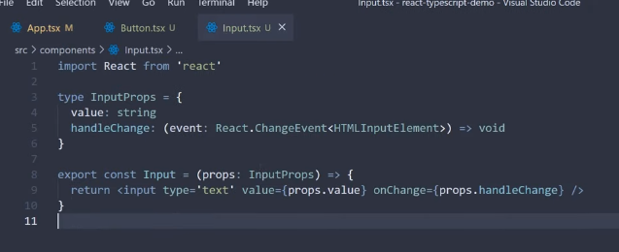

App.tsx – here we are passing the event and value is empty string and logger to event



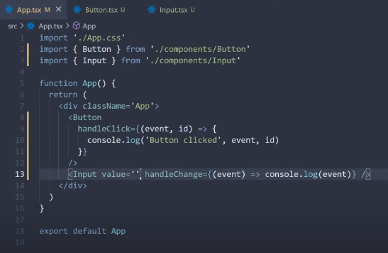

You can pass the event as prop or defined with in component

With in the component is



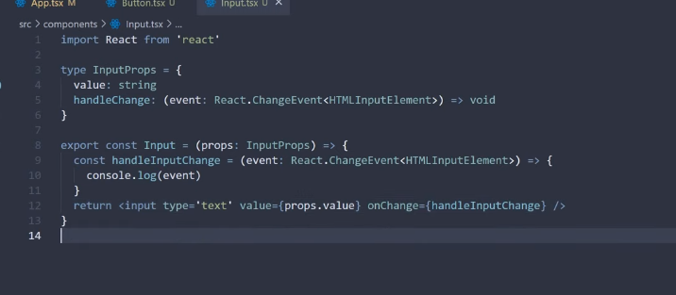

Flow :-

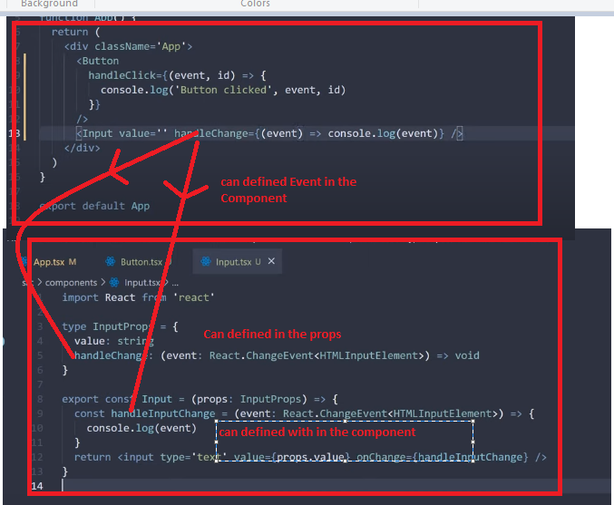

<https://www.youtube.com/watch?v=FNfHtujZE4k&list=PLC3y8-rFHvwgg3vaYJgHGnModB54rxOk3&index=99>

# React TypeScript Tutorial - 7 - Style Props

As we are defined the sytle in the div in the Container component.

In style border, padding and simple text

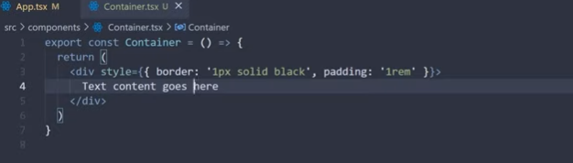

Code valid in the react 17 -need to add the import for the React.Css

Changes in code .. React.CssProperties

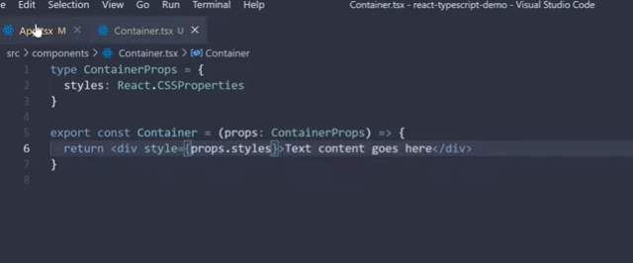

Call the component in the App.tsx

Border, padding are valid and display is wrong

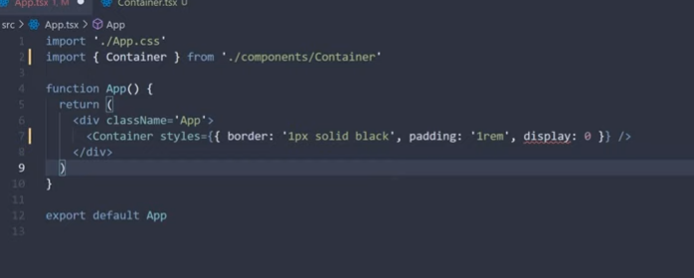

<https://www.youtube.com/watch?v=4Ml7Lp_QcSo&list=PLC3y8-rFHvwgg3vaYJgHGnModB54rxOk3&index=100>

# React TypeScript Tutorial - 8 - Prop Types and Tips

Lets consider the Greet component -props

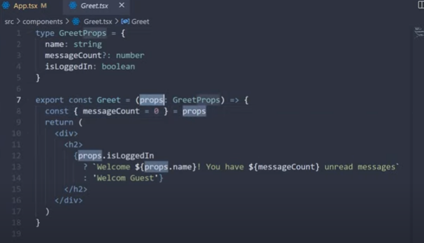

Lets change the props in the below component

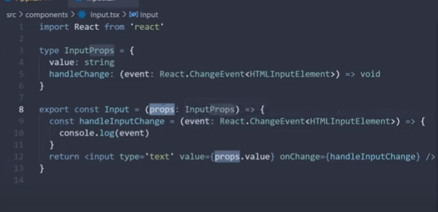

Change in the code

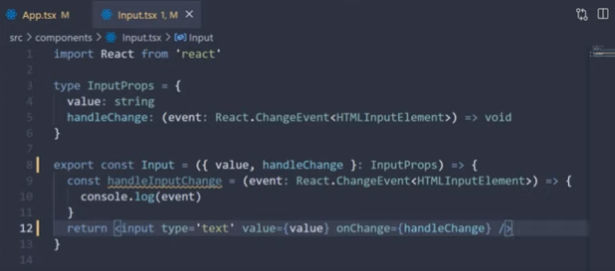

Flow

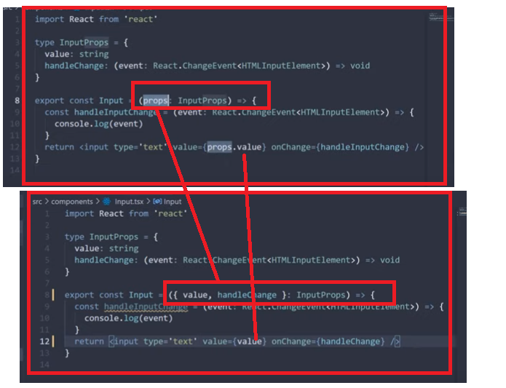

Lets define the separate file for the props – in the Person Component

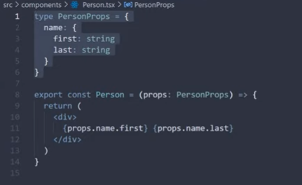

Lets create the person.types –we called as the Action – export type

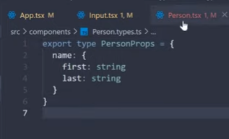

In Component /Action Creator we import the types

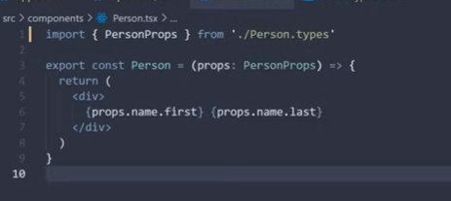

Flow

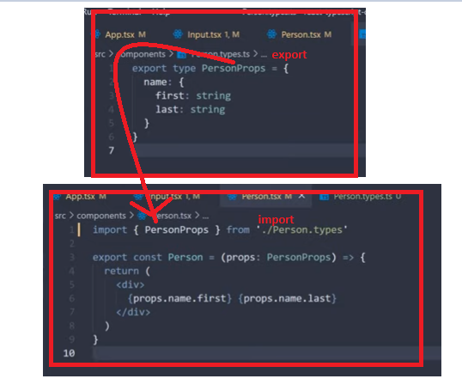

**Re using type :- Make change in code..**

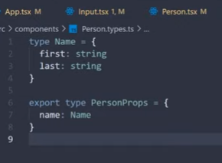

**Add in the below PersonListComponent**

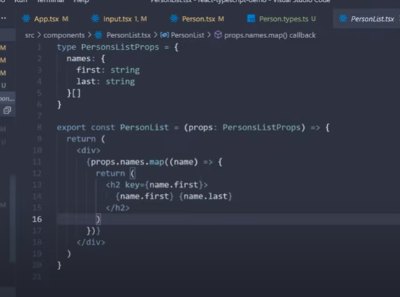

**Change in code.. import Person.types**

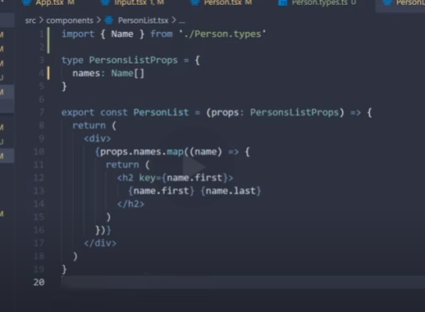

**Flow**

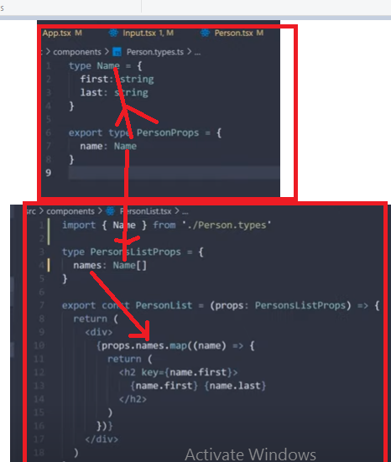

[**https://www.youtube.com/watch?v=2NKNjeB0WVs&list=PLC3y8-rFHvwgg3vaYJgHGnModB54rxOk3&index=101**](https://www.youtube.com/watch?v=2NKNjeB0WVs&list=PLC3y8-rFHvwgg3vaYJgHGnModB54rxOk3&index=101)

# React TypeScript Tutorial - 9 - useState Hook

**Considering the previous component – how we are calling the function**

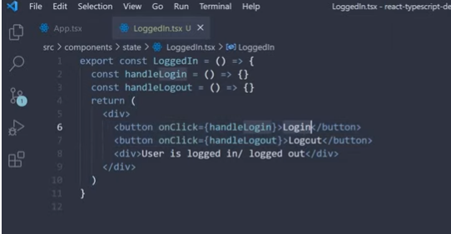

**Here with in the component we have declared two methods/fuctions handlelogin and handlelout and defined in onlick.**

**Let make code changes :-**

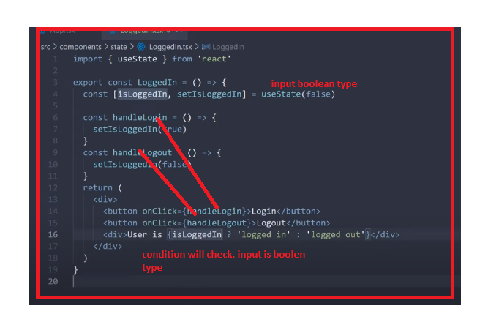

**Hover at the initial value -it will show its Boolean type**

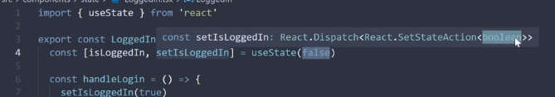

**If you define the string type it will through the error**

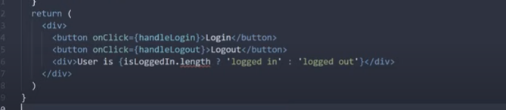

**So it should be**

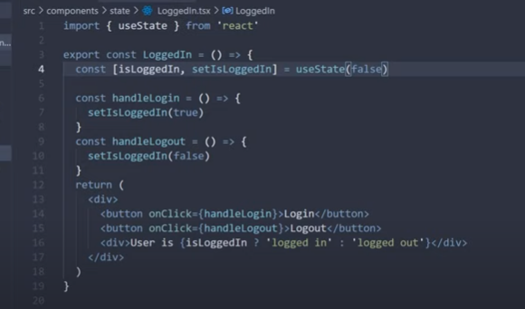

[**https://www.youtube.com/watch?v=LNpWuRUIR5A&list=PLC3y8-rFHvwgg3vaYJgHGnModB54rxOk3&index=102**](https://www.youtube.com/watch?v=LNpWuRUIR5A&list=PLC3y8-rFHvwgg3vaYJgHGnModB54rxOk3&index=102)

# React TypeScript Tutorial - 10 - useState Future Value

**If don’t know the initial value and knows at the future instance only.**

**How to define the code : -**

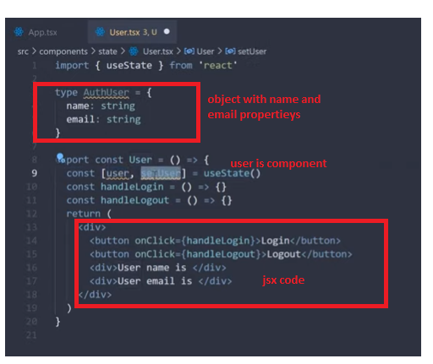

**S1-define initial value and final value is null**

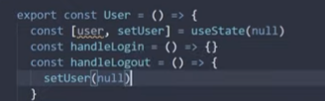

**If you set the value to string – we will get the error- typescript will says your initial value is null**

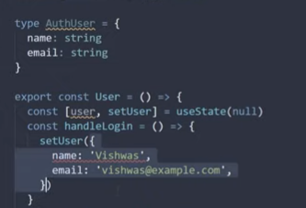

**How to make it accept the AuthUser we have to define in generic**

**useState<AuthUser | null> (null)**

**it will says –intial value be null and but in future can AuthUser**

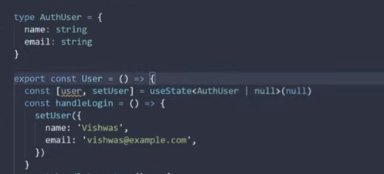

**Explanation**

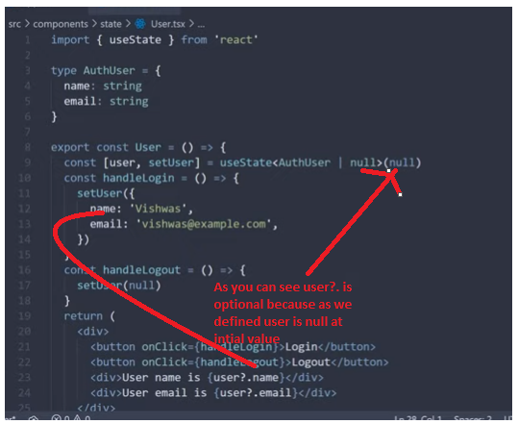

# React TypeScript Tutorial - 11 - useState Type Assertion

[**https://www.youtube.com/watch?v=U3UizPM4aSk&list=PLC3y8-rFHvwgg3vaYJgHGnModB54rxOk3&index=103**](https://www.youtube.com/watch?v=U3UizPM4aSk&list=PLC3y8-rFHvwgg3vaYJgHGnModB54rxOk3&index=103)

**TypeAssertion**

**in the above code – we are option check like name?: naresh- as we are passing the null as initial value – Lets lie to typescript i.e with the empty {} –object**

* **{} as AuthUser - as are saying that We know better then compiler**

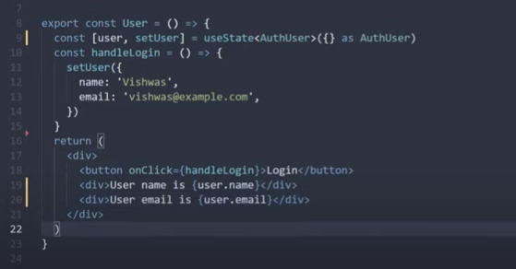

[**https://www.youtube.com/watch?v=lSh9RyYcnPA&list=PLC3y8-rFHvwgg3vaYJgHGnModB54rxOk3&index=104**](https://www.youtube.com/watch?v=lSh9RyYcnPA&list=PLC3y8-rFHvwgg3vaYJgHGnModB54rxOk3&index=104)

# useReducer Hook

**Counter Component**

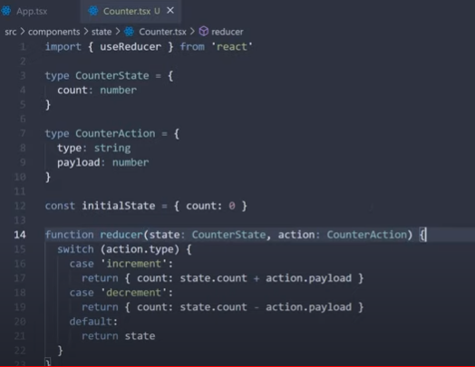

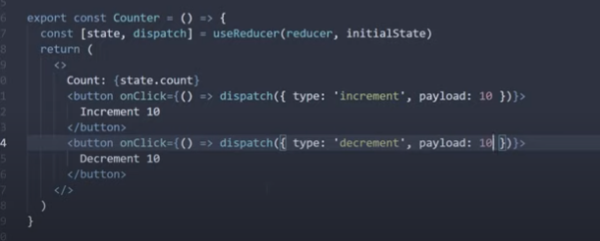

**Flow:-**

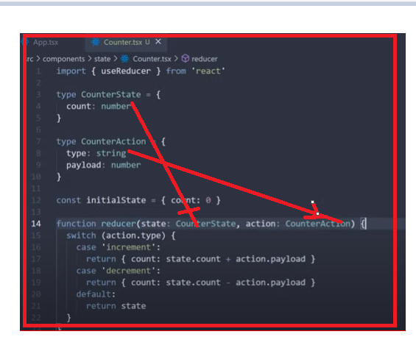

**Try to run the code in the Debug Mode**

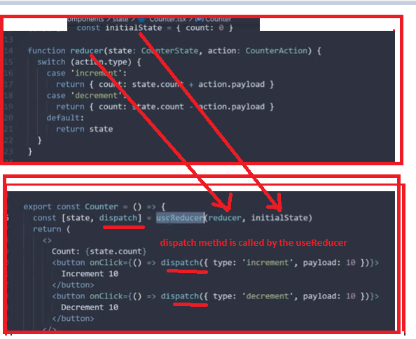

<https://www.youtube.com/watch?v=bcmes6hUO3U&list=PLC3y8-rFHvwgg3vaYJgHGnModB54rxOk3&index=105>

# useReducer Strict Action Types

in the above code we are defining the action type is **String..** so we update



So if the action is **‘increment’** it goes to the case 1 and if action type is **‘reset’- then it will goes to the default state . But it should through the error. How to achieve this.. ?**

**If we passing the action .type is ‘reset’**

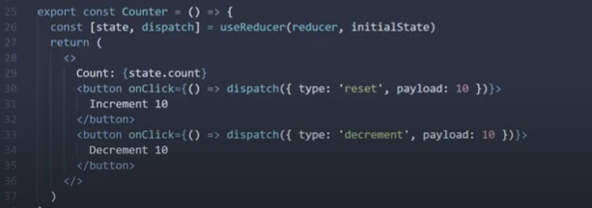

**So make at either increment or decrement**

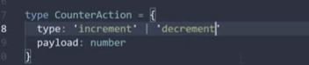

**So now you can see flag in the dispatch method**

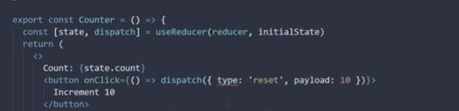

**So update the as ‘increment’ – type is much strict now..**

**Complete code :-**

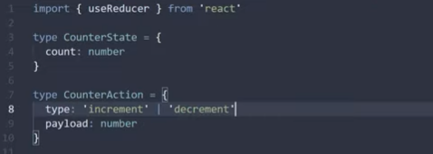

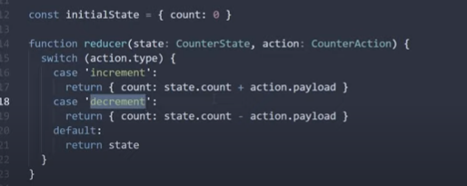

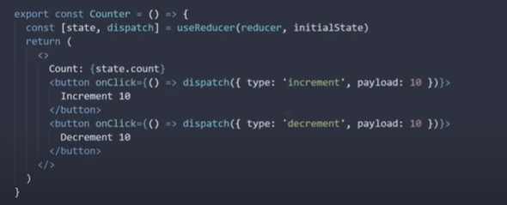

**Lets add reset**

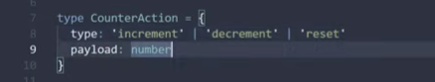

**Reset in the reducer function - just define the initialState**

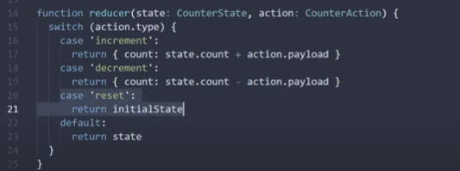

In reset we are not defining the payload value..

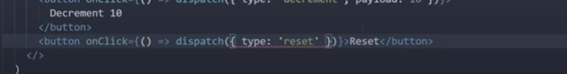

However, you can define the **payload = 0** 

we can the payload is not mandatory for reset - Lets make the **payload is optional**

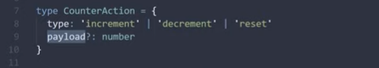

But we are getting the error in the below code- **not accepting the optional** and however, we can pass the pipe line 0 **ie:- –action.payload || 0 which is not acceptable.**

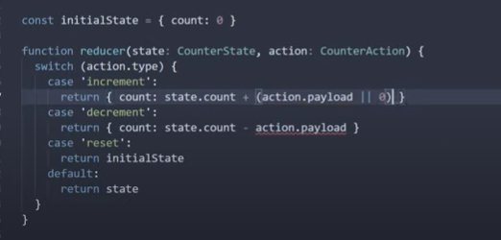

**Let’s make the code changes :-**



**Update action hold increment and decrement having the payload**

**Note : Discreminated Unions and Recommded Approach**

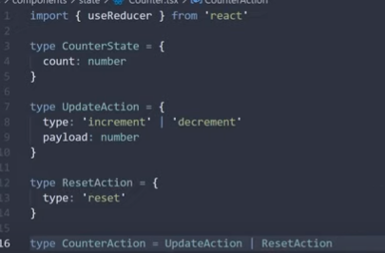

**For resetAction only type ‘reset’-**



**Now the code will fine.**

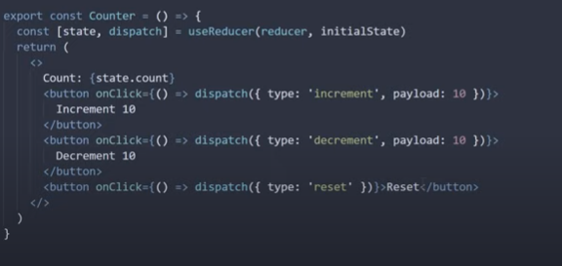

[**https://www.youtube.com/watch?v=rbtTb9hLYS8&list=PLC3y8-rFHvwgg3vaYJgHGnModB54rxOk3&index=106**](https://www.youtube.com/watch?v=rbtTb9hLYS8&list=PLC3y8-rFHvwgg3vaYJgHGnModB54rxOk3&index=106)

**UseContext**

**Theme.ts**

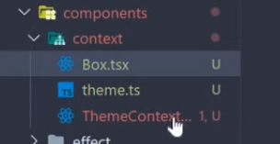

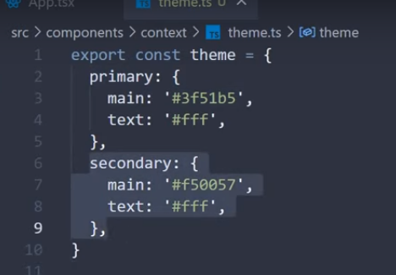

**Box.tsx file**

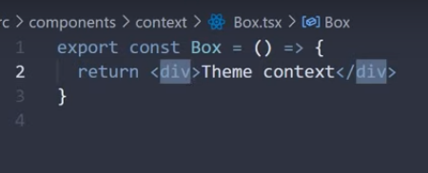

**ThemeContex.tsx (themeContexProvider is the component name)**

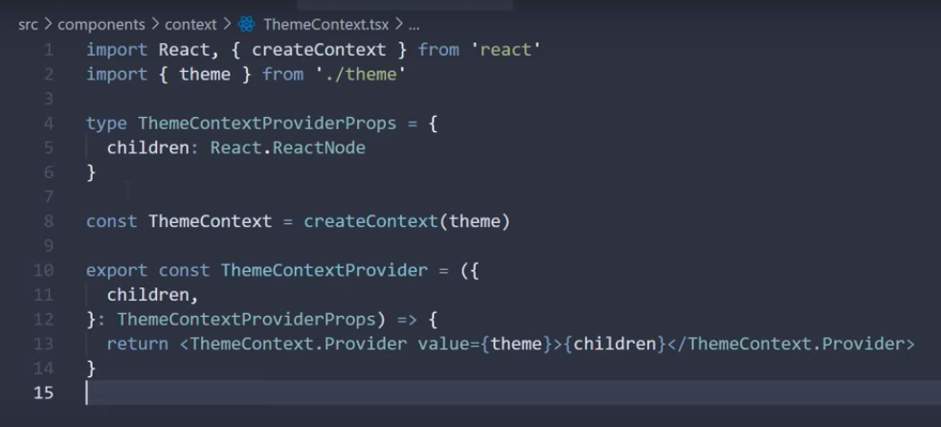

**In App.tsx**

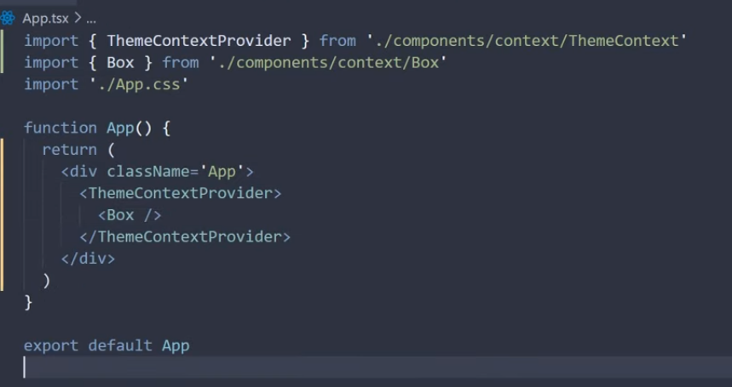

**Let update the box.tsx**

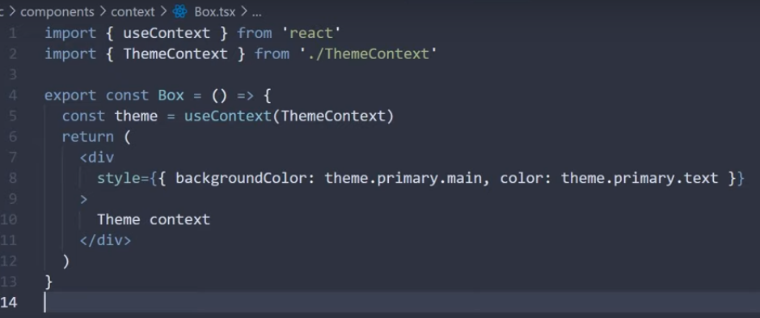

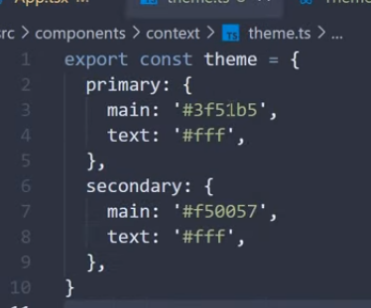

**Flow**

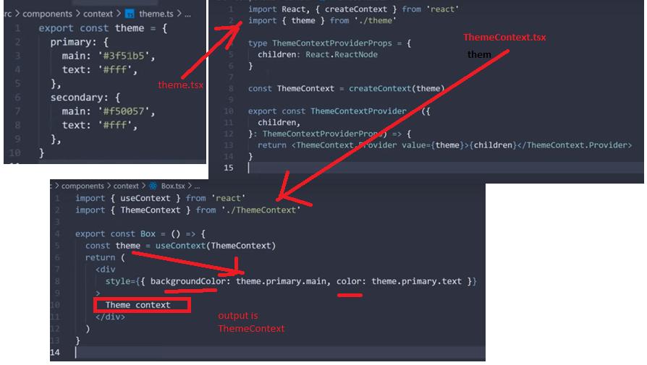

**If you define d the String.. instead of theme you will get the flag..**

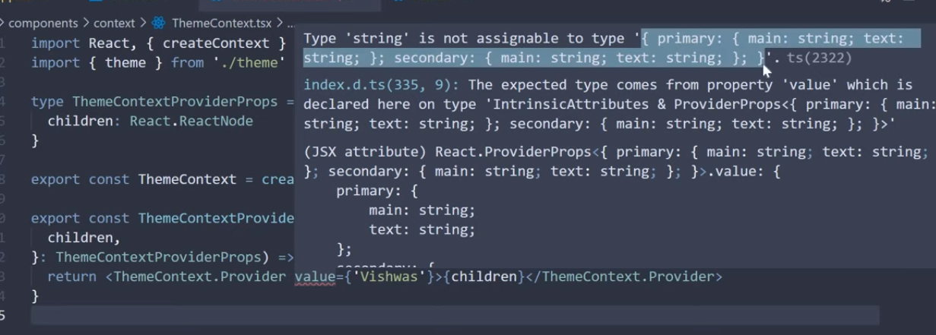

**Here theme is defined and property are .. primary, main and text..**

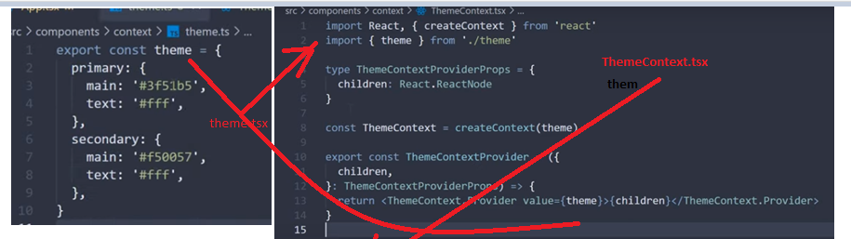

**If you define the theme.success you will get the flag - because.. Primary {main, text }**

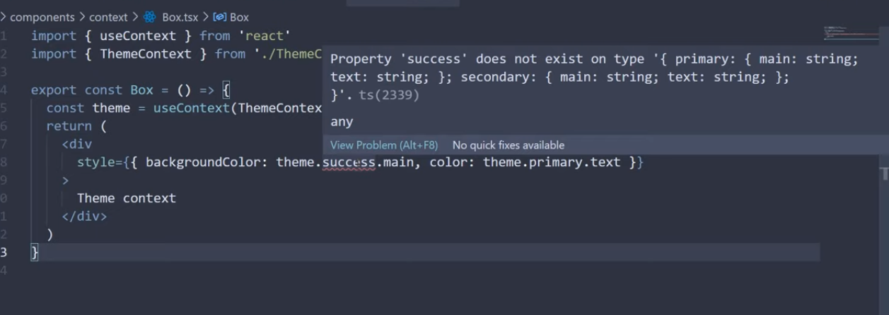

# React TypeScript Tutorial - 15 - useContext Future Value